Internet predecessor of the web

First generation, Computer Centered Processing

To retrieve information from Internet you needed special commands, open terminal, connect to remove system download and only then read the file

Really expensive

1990 arrive the Web

Document center processing

Browser provided an user interface, only to type the link of the document

Not requires expert knowledge anymore

Huge growth

Web not only documents, we now also connect all kind of devices (household devices) **Internet of things**

Huge growth of data in the web

Web based on markup language HTML, describes how the information is presented in the web and how the information is linked with each other

HTML does not describe what the information really means, primarily intended for humans and not for the support of machine

**Information retrieval dilemma**:

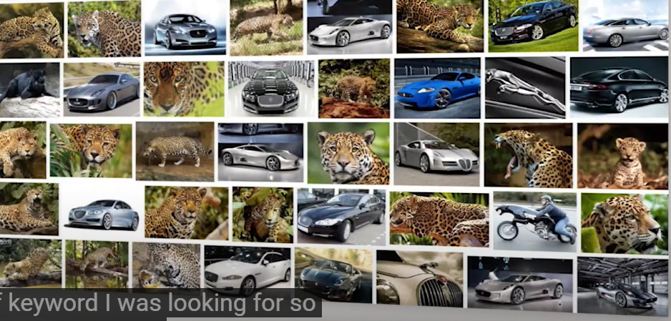

Jaguar ambiguous term (polysemy: a word can have different meanings)

also we can express the same content with different words (synonyms and metaphors)

**Implicit knowledge:** the information does not always need to be specified explicitly, sometimes must be derived from logical deductions from the available information

